MEMORANDUM OF UNDERSTANDING
Between

The Association of Professional Accountants and Auditors
of the Republic of Moldova and
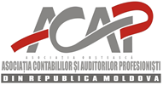

ICFM UK Ukraine and ICB Global
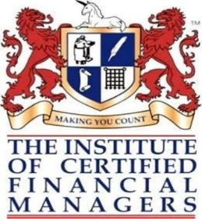

Accountants union of Georgia
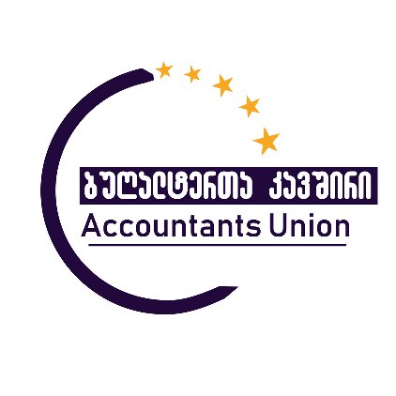

Association of Professional Financial Managers of Azerbaijan APFM

Date: April 2021 .

For the purpose of strengthening the good cooperation relations and the development of the accounting and auditing profession, the Association of Professional Accountants and Auditors of the Republic Moldova, ICFM UK Ukraine and ICB Global, Accountants Union of Georgia and Association of Professional Financial Managers of Azerbaijan APFM
and the Accountants union hereafter referred to as “Parties”, agreed to conclude this memorandum of understanding:
-1-
- In the view of promoting and developing the accounting and auditing profession within the economic environments of the two countries;
- In view of promoting the convergence to International Standards on Auditing, that lead to financial reporting improvement at national level.
The two Parties agreed the following:
The Parties will jointly promote the following objectives:
- Reciprocal support in the organization and functioning of the members’ continuous professional development programs (CPD).
- Reciprocal support in the field of ethics, education and quality in the activities performed by financial auditors, members of the two professional organizations.
- Reciprocal consultation on various issues significant for the profession, at European and international level.
- Common attendance and support to national or international events (seminars, conferences, professional manifestations led by two organizations).
- Exchange of publications (books, magazines) and other materials published by the professional bodies; exchange of articles relevant for the accounting and auditing profession in the magazines of the bodies and/or on the website of each organization.

- The projects and activities financing is agreed upon separately, in accordance with the individual programs, based on the agreements reached by the decision-making authorities of the two organizations.

- The Association of Professional Accountants and Auditors of the Republic of Moldova and the Accauntants union will act in the light of strengthening the cooperation, the exchange of information and experience and will offer one other assistance, according to the agreements reached in this regard.

-2-
The Association of Professional Accountants and Auditors of the Republic of Moldova
Mitropolit Valaam street, off. 434, 439 Chisinau, Republic of Moldova
Mail: info@acap.md Tel. +373 22 54-14-12, 54-14-95

President: Georgeta COVALIOV-RUSU _________________________

ICFM UK Ukraine and ICB Global
Office 9, 13 Provulok Tarasa Shevchenka,
Maidan Nezalezhnosti, Kyiv , Ukraine, 01001
+ 38 044 461 94 62 bcp@icfm.org.ua
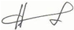
Director : Helen Khorikova

The Accountants Union of Georgia
Tbilisi, Kodalo Street, off 12.
Tel:+995598000 640 mail:bugaltertakavshiri@gmail.com

Director: Tatiana Beridze ______________________________________

Association of Professional Financial Managers of Azerbaijan APFM
Azerbaijan.Baku, Y.V.Chamanzaminli Str, 3rd floor. Mail: office@apfm.az

Chairman: Nuriyya Novruzova _________________________

