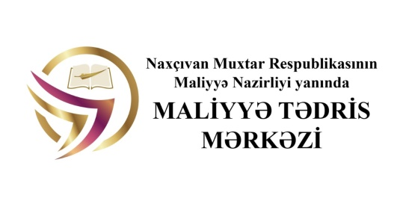
Financial Training Center under the Ministry of Finance of Nakhchivan Autonomous Republic

AND

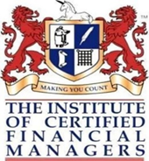

ICFM UK Ukraine and ICB Global

COOPERATION M E M O R A N D U M

NAXÇIVAN– 2021

Nakhchivan, 17 October, 2021
Article 1
Parties and duration of the memorandum:

This Memorandum of Cooperation (hereinafter referred to as the "Memorandum") shall be signed between the following organizations, hereinafter referred to as the "Parties":
- Financial Training Center under the Ministry of Finance of Nakhchivan Autonomous Republic
- ICFM UK Ukraine and ICB Global
Article 2
The subject of this memorandum is cooperation on creating favourable conditions for the development of accountants, auditors and other allied professions (hereinafter referred to as “Specialists”) in the territories of the Parties:
- Interaction regarding the professional development of the Specialists of both Parties, creating favourable conditions for business communication between experts of the Parties
- Cooperation in the development of professional certification through the network of both Parties training centers for training and professional development of the Specialists
Article 3
The main directions of cooperation between the Parties are:
- cooperation on organizing international conferences;
- organization of cooperation in the field of training, education and professional development;
- mutual consultations in order to submit offers on issues of mutual interest;
- participation of the Parties representatives in coordinated professional events;
- organization of information exchange regarding professional activities of the Parties, including publications, national regulatory documents on accounting and auditing which are of the Parties interest;
- performing other coordinated actions aimed at the development of the Parties professional activity;
- interaction with foreign and international professional organizations and associations;
- presenting the results of implementing this Memorandum on the websites of the Parties.

Article 4
The Parties will support mutually arranged educational programs, projects and events.
Article 5
The Parties will cooperate in acheiving common objectives in accordance with the interests of each Party of this Memorandum.
Article 6
When implementing the Memorandum the Parties will maintain business contacts and assume the necessary measures to ensure the efficiency and the development of business of each other.
Article 7
In the achievement of the determined aims the Parties will cooperate on the basis of equality, mutual trust, honest partnership and protection of the interests of each other.
Article 8
Activities of the Parties shall be based on mutual interest in creating favorable conditions for implementation of joint programs on the basis of mutual respect, professional and commercial interests and the principle of most favored nation treatment, which means providing to each other the agreed benefits and privileges.
Article 9
Cooperation between the Parties is to be performed in strict accordance with the legislation of the Parties, generally accepted principles and international agreements.
Article 10
When cooperating the Parties shall comply with the necessary confidentiality requirements regarding received information.
Article 11
This Memorandum does not impose any specific financial and legal obligations. The
Article 12
All addendum and adjustments to this Memorandum shall be made in writing and shall be signed by authorized representatives of the Parties.
Article 13
This agreement is made in four copies, each copy in English and Azerbaijan with equal legal force.
Article 14
This Agreement is concluded for an unlimited term and shall go into effect after it is signed by both Parties. It may be terminated at any time by written agreement of the Parties.

Financial Training Center under the Ministry of Finance of the Nakhchivan Autonomous Republic  Nakhchivan city, AZ 7000, Nagi Aliyev street2  _______________  (signature)  Mehriban Imanova  Director of Financial Training Center under the Ministry of Finance of the Nakhchivan Autonomous Republic  Stamp | ICFM UK Ukraine and ICB Global  Office 9, 13 Provulok Tarasa Shevchenka,  Maidan Nezalezhnosti, Kyiv, Ukraine, 01001  +38 044 461 94 62 bcp@icfm.org.ua  _________________  (signature)  Olena Khorikova  Director of ICFM UK Ukraine and ICB Global  Stamp

