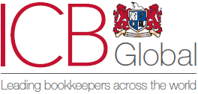
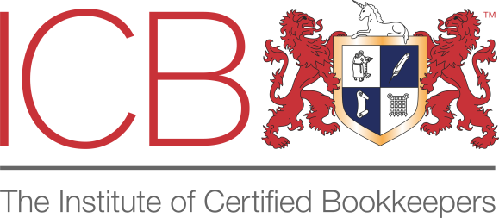

ICB- Certificate in Accounting (accredited program)
 | Syllabus | hours
1 | The concept of enterprise. Information on the establishment of enterprises, registration and preparation of primary documentation, taxpayers' obligations, opening bank accounts, electronic services | 3
2 | Information on types and sizes of accounting, forms of accounting, documentation, inventory, calculation, double entry, national chart of accounts and balance sheet | 6
3 | Accounting concepts and accounting policy. Capital and current expenses and revenues | 4
4 | Non-current assets: Accounting for fixed and intangible assets | 6
5 | Inventories: Material inventories, production costs, finished goods, goods and other inventories. In-farm movement of resources. | 4
6 | Short-term and long-term receivables, other long-term and short-term financial assets and other long-term and short-term assets | 3
7 | Cash and cash equivalents: Cash, cash transfers, bank accounts, cash equivalents and VAT sub-account | 3
8 | Long-term and short-term payables (accounts payable to suppliers and contractors, payroll staff, founders for dividends, lease, construction contracts and interest, bank loans and other loans) | 6
9 | Revenues: Sales, other operating, financial and extraordinary income | 3
10 | Costs: Cost of sales, administrative, commercial, financial emergency, etc. operating expenses | 3
11 | Accounting for salary settlements with employees. Accounting for settlements with unaccounted persons. Travel accounting | 6
12 | Initial trial balance. Correction of errors | 3
13 | Components of financial statements. Profit and loss statement | 6
14 | Statement of financial position (balance sheet) | 6
15 | Cash flow statement and statement of changes in equity | 6
16 | Value Added Tax, Withholding Tax, Property Tax, Land Tax, Unified Declaration, Income Tax Return Procedure | 12
17 | Practical accounting (practical experience on enterprise "X") | 40
 | Total | 120

